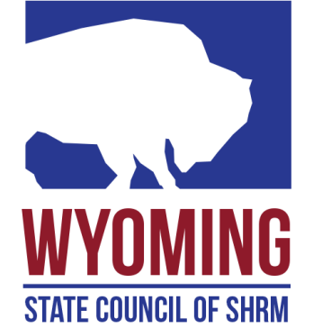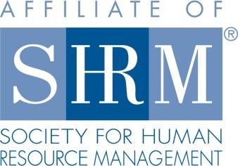

**Social Media Director**

**Function:**

Promotes the SHRM Mission to empower people and workplaces by advancing HR practices and by maximizing human potential.

Promotes awareness of the purpose and actions of the council through ongoing communication efforts and branding initiatives, using the social media tools. Make sure that HR professionals, both within and without SHRM are fully informed of council resources and activities by using existing and developing social media. Works closely with other council members to ensure that the council is portraying a consistent and professional image to its members and to the business community at large.

**Responsible To:**

* The State Council Director

**Responsibilities:**

* Serves as a voting member of the council. Attends and participates in all meetings of the council.
* Evaluate the social media landscape and decide what platforms will be good tools for the state council.
* Work to understand and develop an effective strategy for use of new media.
* Develop a cyberspace persona and become immersed in the culture and use of new media as a representative of the council.
* Work to educate other state council members about the use of new media, both from a technical perspective and from a business approach. Plan to host a session on new media at the state conferences.
* Work to educate other local SHRM chapters about the use of new media, both from a technical perspective and from a business approach.
* Develop and implement a strategy to use new media in promoting and presenting our state conference. This includes advocating for blog panels, free conference wireless internet and social media conference space.
* Develop relationships with SHRM to understand SHRM’s position on social media, and to help promote this position at the state and local level.
* Consult with other state council representatives to compare best practices on use of new media, in various applications, and how they are used to promote state councils. State conferences and chapters.
* Work with the state conference chairperson to ensure a strong social media presence at the state conference.
* Performs other related projects as agreed upon.

**Requirements:**

* Must be a SHRM national member in good standing. SHRM Certification is highly desirable.
* Appointment is made by a majority vote of the State Council.