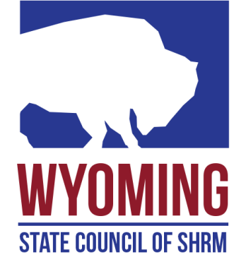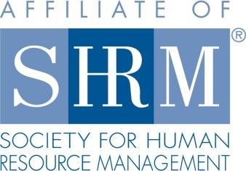

**Secretary**

**Function:**

Promotes the SHRM Mission to empower people and workplaces by advancing HR practices and by maximizing human potential.

Prepares the proceedings of all state council meetings, takes minutes, and maintains the records.

**Responsible To:**

* The State Council Director

**Responsibilities:**

* Serves as a voting member of the state council and is expected to attend and participate in all meetings of the council.
* Prepares and distributes meeting announcements and a draft agenda; prepares follow-up material, ensures records accurately reflect business matters and prepares reports associated with council meetings and activities.
* Prepares minutes of council meetings and ensures appropriate distribution including copies to other council members and the SHRM Regional Team.
* Recommends new policies and procedures to increase organizational effectiveness.
* Performs other duties as assigned by the state director.

**Requirements:**

* Must be a SHRM national member in good standing. SHRM Certification is highly desirable.