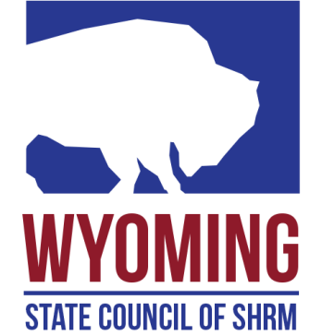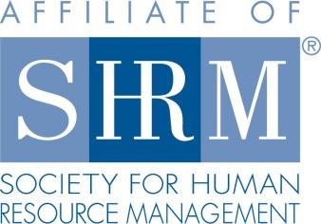

**Membership Director**

**Function:**

Promotes the SHRM Mission to empower people and workplaces by advancing HR practices and by maximizing human potential.

Responsible for growing and retaining SHRM and Dual Membership in the state. The Director works closely with all Chapter Membership Directors, Chapter Presidents, District Directors, and State Council members on plans to engage/retain existing members and attract new members. She/He Champions membership initiatives for the State and leads the way for chapters to grow Dual Membership (both SHRM and chapter membership).

She/he is responsible for state-wide outreach and leverages connections wherever possible.Provides training to chapters and members on how to utilize SHRM member benefits, the value of benefits, etc.

**Responsible To:**

* The State Council Director

**Responsibilities:**

* Prepares annual SHRM membership growth goals for the state, works with all chapters to help them develop their annual growth goals and plans to achieve the goals.
* Monitors and shares state-wide and chapter membership metrics with the state council and chapters to track increases or decreases in membership in a timely fashion and take action as appropriate.
* Develops and executes short-term and long-term membership goals for the state. Works with each chapter on their membership goals to ensure the chapters are set up for membership success.
* Plans membership initiatives for all State Council events. Provides engaging membership promotions and activities to encourage Dual Membership. Sets a goal for each event and tracks outcomes.
* Communicates Dual Membership benefits (via eBlasts, website, social media, etc.) to attract At-Large members in the state to join a chapter.
* Trains and meets with Chapter Membership Directors to ensure they are aware of their responsibilities and provides training on accessing resources on the Volunteer Leaders Resource Center (VLRC).
* Helps State Council members, Chapter Membership Directors, District Directors, Chapter Presidents and others learn about the value of Dual Membership. Disseminate information on how Dual Membership can advance their career and benefit their organization.
* Collects successful membership recruitment/retention initiatives to share with chapter membership directors.
* Provides forums - e.g. state council meetings, conference calls, webinars - for chapter membership directors to share successful recruiting/retention practices and to discuss membership issues.
* Serves as a resource for those chapters struggling to meet minimum standards in SHRM membership to assure that chapters are not disaffiliated for not meeting this requirement.
* Attends state leadership conferences and state council meetings to assure representation for this critical area of responsibility. May attend chapter board meetings as requested to communicate/promote membership strategies and provide updates.
* Collaborates with other state council members on membership initiatives to ensure a continued focus on Dual Membership.

**Requirements:**

* Must be a SHRM national member in good standing. SHRM Certification is highly desirable.
* Should be able to visit Chapters throughout the State.
* Appointment is made by a majority vote of the State Council.