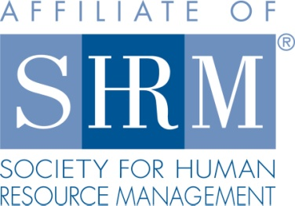
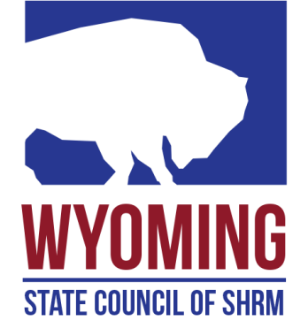

Wyoming State SHRM Council

Achievement Award Application

Name: Date Submitted:

Mailing Address: ________________

Email address: ____

Company: Position:

National SHRM member SHRM Chapter Member Non member

To be considered for the $750.00 award you must have passed the certification exam in the past 12 months and your Certification expenses must not have been paid by your employer. Application Deadline is July 1st. The scholarship will be awarded during the Wyoming State Conference in September of each year.

Type of Certification Received:
SHRM - CP
SHRM - SCP
Date Certification Received:

Please attach a summary telling us briefly about yourself, your experience getting your certification, and why you wish to be considered for the award. Also please attach your proof of certification.

Applicant Signature: Date:

Submit your completed application and supporting materials via email to the Wyoming State Council Certification Director: wyomingshrm@yahoo.com

